**Gloucestershire Constabulary**  
Police Headquarters  
No.1 Waterwells, Waterwells Drive  
Quedgeley, Gloucester. GL2 2AN  
[**www.gloucestershire.police.uk**](http://www.gloucestershire.police.uk)

Police Information Point

**Have you got any police/community related issues or concerns?**

**Come and meet your local PCSO and discuss them.**

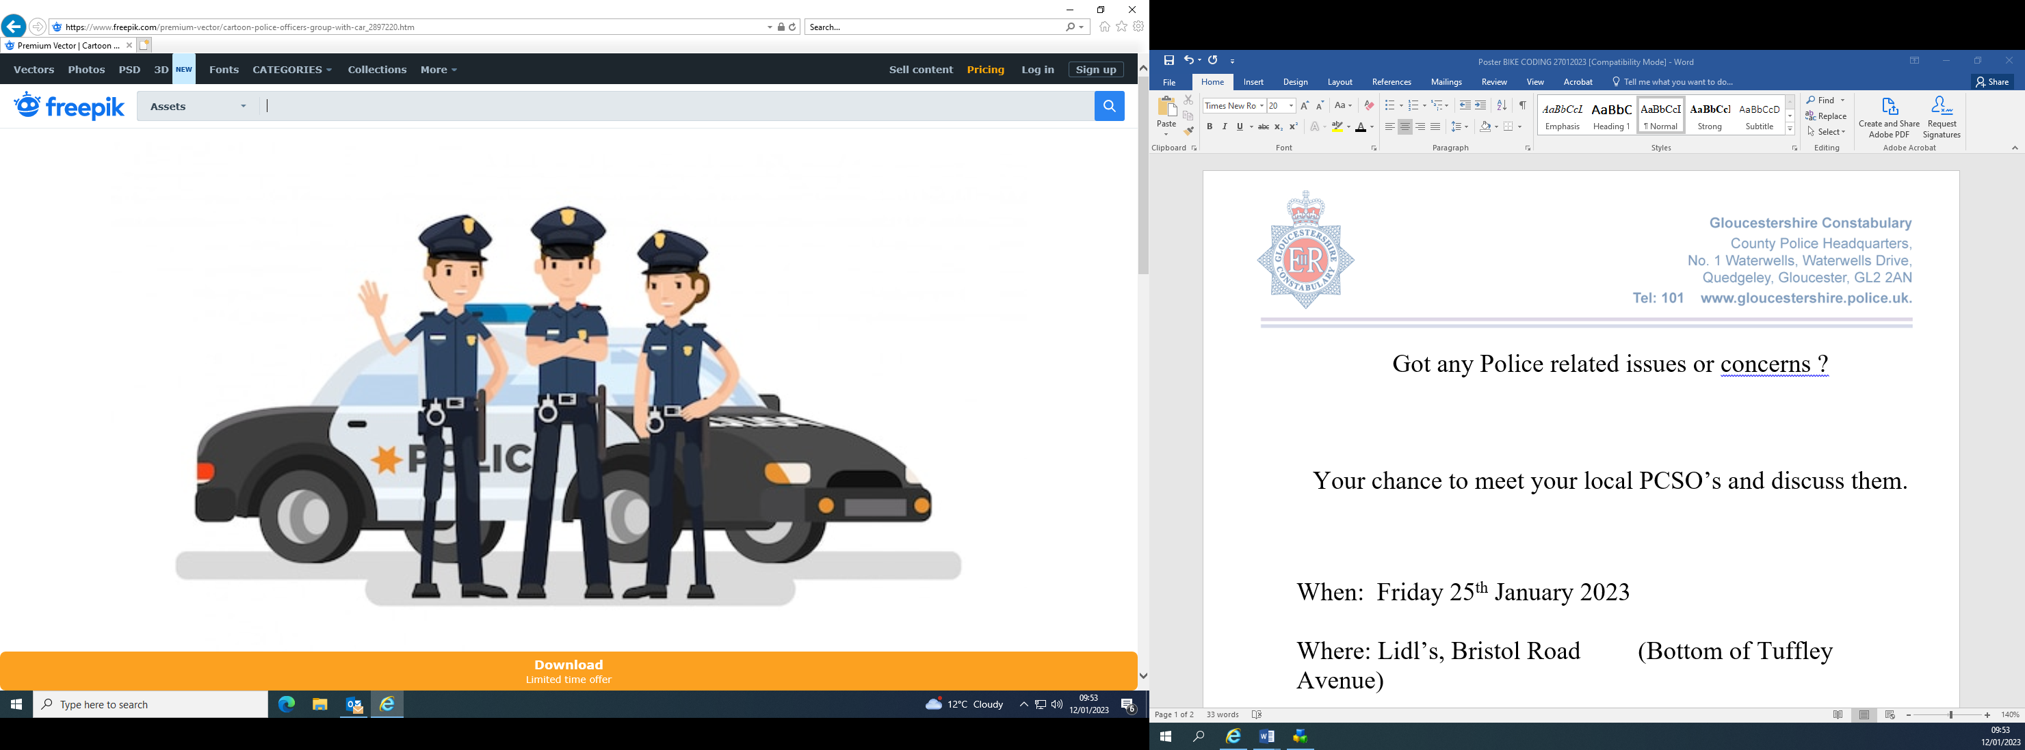

**When:** Tuesday 26th August 2025

**Time:** 10:00am – 13:00pm

**Where:** Hunts Grove Primary Academy